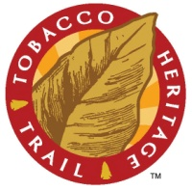
TOBACCO HERITAGE TRAIL
ROANOKE RIVER RAILS TO TRAILS, INC.

APPLICATION FOR TRAIL USE PERMIT

Date of Application:
Requesting Party or Organization (if applicable):
Contact Name:
Address:
Phone:
Fax:
Email:

Location of Request (town and/or county):
Tax parcel(s):

Permit Type (check one):
New Access (drive, farm use, etc)
Upgrade to existing access
Easement (utility, parking, etc)
Timber Harvest
Hunting – access to land
Encroachment Remedy
Special Event related activity:
Other:

Description of proposed trail use or activity:

Dates and time of Proposed Activity (if applicable) From: To:
Attach plat, parcel map & location map. (unless applying for an event)

Prior to our event we have inspected the section of the Tobacco Heritage Trail that we intend to use and found it satisfactory and free of any hazards.

Signed: ___________________________________________________________________________________

NOTE: Applications for all permits must be received at least 30 days prior to Board meetings.

